**Practical Robotics Projects with Arduino**

**(CSE 4571)**

**Lab Assignment No – 08**

**Bluetooth Communication**

**Submission Date: _______________**

|  |  |  |
| --- | --- | --- |
| **Branch: CSE Section:** | | |
| **Name** | **Registration No.** | **Signature** |
|  |  |  |

Department of Computer Science and Engineering

Institute of Technical Education and Research (Faculty of Engineering)

**Siksha 'O' Anusandhan (Deemed to be University)**

**Bhubaneswar, Odisha-751030.**

# Aim:

# To interface an HC-05/HC-06 Bluetooth module with Arduino UNO for wireless serial communication between the Arduino and a Bluetooth-enabled device.

# Objectives:

1. **To gain familiarity with the HC-05/HC-06 module and Arduino UNO serial communication.**

* Learn the pin configuration (VCC, GND, TXD, RXD, EN/KEY) of the HC-05/HC-06 module.
* Understand the role of baud rate, pairing code, and serial communication protocol.

1. **To establish a basic wireless link between Arduino UNO and a smartphone/PC.**

* Connect the HC-05/HC-06 module to the Arduino UNO (using SoftwareSerial).
* Write a simple Arduino sketch to send and receive data over Bluetooth.
* Pair the module with a smartphone/PC using a Bluetooth terminal app and verify successful two-way communication.

1. **To implement bidirectional communication and LED control.**

* Build an external circuit with an LED connected to Arduino digital pin 6.
* Modify the Arduino program to turn the LED ON when the smartphone sends the character 1, and OFF when it sends 0.
* Send acknowledgment messages back to the smartphone (e.g., “LED ON” / “LED OFF”).

1. **To Evaluate communication performance.**

* Test and record the effective communication range of the Bluetooth module.
* Measure response latency between sending a command (from phone) and Arduino execution.

# Pre-Lab Questionnaire:

**A. Experiment-Specific**

1. Name all the pins of the HC-05/HC-06 module and their functions.
2. Why is a voltage divider required between Arduino TX and HC RX?
3. What is the default baud rate of the HC-05/HC-06 module?
4. Explain the difference between HC-05 and HC-06 modules.
5. What is Software Serial in Arduino, and why is it used in this experiment?
6. What is the purpose of pairing a Bluetooth device before communication?
7. How does Arduino interpret commands sent from a smartphone?
8. How can you verify if the HC-05/HC-06 module is powered and ready for pairing?
9. List the factors that can affect Bluetooth communication range.
10. Explain the role of the Serial Monitor in this experiment.

**Answers to Pre-Lab Questions**

**Components/Equipment Required:**

|  |  |  |  |
| --- | --- | --- | --- |
| **Sl.**  **No.** | **Name of the**  **Component / Equipment** | **Specification** | **Quantity** |
| **1)** | Arduino UNO R3 | 16MHz | 1 |
| **2)** | Arduino UNO cable | USB Type A to Micro-B | 1 |
| **3)** | HC-05 / HC-06 Bluetooth Module | Bluetooth 2.0 SPP, 3.3V TTL logic, default baud rate 9600 bps | 1 |
| **4)** | Resistors (carbon type) | 220Ω / 2.2kΩ/ 1 kΩ | 1 each |
| **5)** | LED | Any colour of your choice | 1 |
| **6)** | Breadboard | 840 Tie points | 1 |
| **7)** | Smartphone with Bluetooth / PC with Bluetooth | Android/iOS device or Windows PC, for testing wireless serial communication | 1 |
| **8)** | Bluetooth Terminal App | Android/iOS app like “Serial Bluetooth Terminal” or “Bluetooth Terminal | 1 |
| **9)** | Jumper Wire | --------------------------- | As per requirement |

**Objective 1**

**To Gain familiarity with the HC-05/HC-06 module and Arduino UNO serial.**

## Circuit / Schematic Diagram

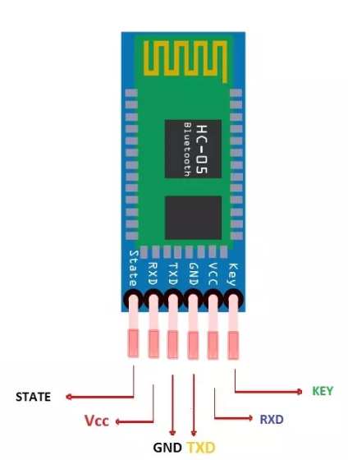 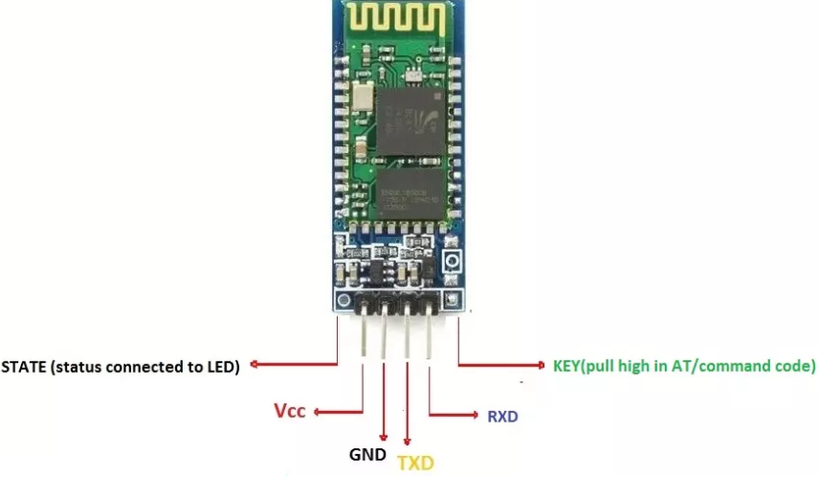

**Figure 1:** *HC-05/HC-06 module Pinout*

## Observation

**(Write how you have done the connection between the Bluetooth module and Arduino uno)**

**Objective 2**

**To establish a basic wireless link between Arduino UNO and a smartphone/PC.**

## Circuit / Schematic Diagram

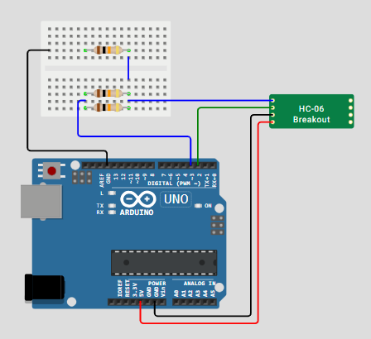

**Figure 2:** *Interface between Arduino UNO and HC-05/HC-06 module*

## Code

## Observation

**Figure 3:** *Interface of Arduino UNO with HC-05/HC-06 module (Tinkercad)*

**Figure 4:** *Interface of Arduino UNO with HC-05/HC-06 module (WokWi)*

**Figure 5:** *Interface of Arduino UNO with HC-05/HC-06 module (Hardware)*

# Objective 3

**To implement bidirectional communication and LED control.**

## Circuit / Schematic Diagram

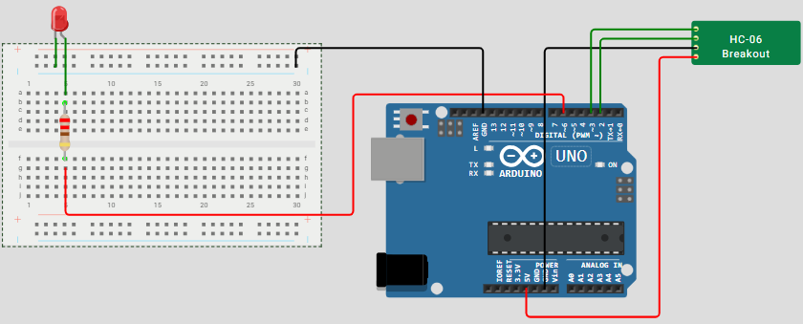

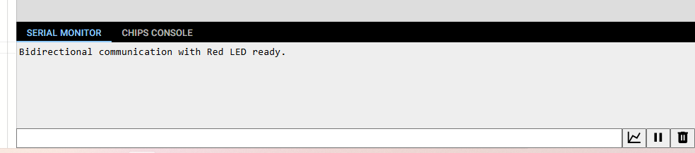

**Figure 6: *Interface HC-06 and Arduino UNO for bidirectional communication and LED control and confirmation in serial monitor window***

## Code

**Observation**

**Figure 7: *Interface HC-06 and Arduino UNO for bidirectional communication and LED control and confirmation in serial monitor window (Tinkercad)***

**Figure 8: *Interface HC-06 and Arduino UNO for bidirectional communication and LED control and confirmation in serial monitor window (WokWi)***

**Figure 7: *Interface HC-06 and Arduino UNO for bidirectional communication and LED control and confirmation in serial monitor window (Hardware)***

Objective 4

**To Evaluate communication performance**

## Circuit / Schematic Diagram

****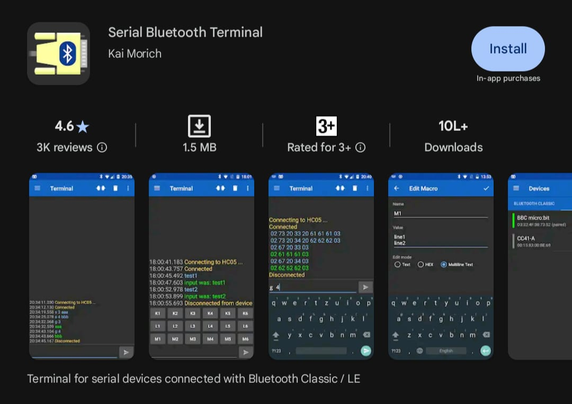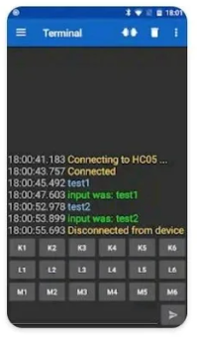**

**Figure 8: Establish connection with the Serial Monitor and Mobile Phone**

**Code**

## Observation

Figure 9: Test, record and Measure response latency (Hardware)

**Conclusion:**

**Precautions:**

**Post Experiment Questionnaire:**

1. How did you establish bidirectional communication between Arduino and a smartphone?
2. Describe the steps to control an LED using Bluetooth commands.
3. What was the maximum reliable communication range achieved during the experiment?
4. How did you implement forwarding between Serial Monitor and Bluetooth?
5. What challenges did you face while pairing the HC-05/HC-06 module?
6. Explain how the Arduino code processes different commands (1 = ON, 0 = OFF).
7. How would you modify the setup to control multiple LEDs with different commands?
8. Compare the observed LED behavior when using Serial Monitor vs. smartphone commands.

___________________________________________

|  |  |
| --- | --- |
| **(Signature of the Faculty)** | **(Signature of the Student)** |
|  | **Name:** |
| **Date:** | **Registration No.:** |
|  | **Branch:** |
|  | **Section** |